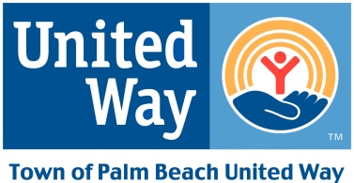

TOWN OF PALM BEACH UNITED WAY
ALEXIS DE TOCQUEVILLE DISTINGUISHED CITIZEN AWARD 1990-PRESENT
The Distinguished Citizen Award recognizes outstanding contributions by individuals whose generosity and dedication is motivated by the desire to improve the quality of life for all citizens in our community. Each year, we honor an individual or individuals who display the highest level of commitment to serving our community.
2019 Norma and Bill Tiefel
2018 Jana and John Scarpa
2017 Michele Kessler
2016 Tom Quick
2015 Danielle Hickox Moore
2014 Patricia Cook
2013 Bud Tamarkin
2012 Stanley Rumbough
2011 Lesly Smith
2010 Marjorie Fisher
2009 Sydelle Meyer
2008 Daniel Ponton
2007 Ruth and Edward Hennessy
2006 Bob and Mary Montgomery
2005 Ruth and Carl Shapiro
2004 Nicki and Ira Harris
2003 Paul Leone
2002 Gene Ribakoff
2001 Anita Michaels
2000 Christine Curtis
1999 Mary Alice Fortin
1998 Helen Cluett
1997 Sidney Kohl
1996 Edward Cook
1995 Alex Dreyfoos
1994 Ann Appleman
1993 John Brogan
1992 Nate Appleman
1991 Frances Hufty
1990 Doyle Rogers

